T Stats - T Test and Hypothesis Testing:

One sample T test problem:  
Q. In the population the average IQ is 100. A team of researchers want to test a new medication to see if it has a positive or negative affect on intelligence, or no effect at all. A sample of 30 participants who have taken the medication has a mean of 140 with a standard deviation of 20. Did the medication affect intelligence. CI = 95%.

Given,

$μ=100$

n = 30, i.e, n >= 30

$\overline{x}=140$

s = 20

CI = 95%

Significance value = $α$ = 1 – 0.95 = 0.05

To see whether it is increasing or decreasing, makes it a two tailed test.

1. Null Hypothesis () =

2. Alternate Hypothesis () = (2 tailed test)

3. Significance value = 0.05

4. Degree of freedom = n – 1 = 29

5. Decision Rule:

Based on the visualization diagram of the distribution, we need to find out the Z score by using the T table, cross referencing using Significance Value and Degree of Freedom and Tail type of test.

Cross referencing the T table, we get the Z score as 2.045 which is how many standard deviation is the extreme away from the mean

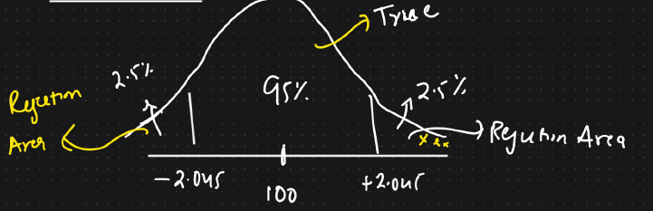

We will calculate the T test.

If T test is less than -2.045 or greater than +2.045 then we reject the null hypothesis.

Else we fail to reject the null hypothesis.

6. Calculation Test Statistics:

t = $\frac{\overline{x}- μ}{\frac{s}{\sqrt{n}}}$ = $\frac{140-100}{\frac{20}{\sqrt{30}}}$ = 10.96

Since t is greater than +2.045, we reject the null hypothesis.

Final conclusion: The medicine has affected the intelligence. Further, the medication has increased the intelligence (since t value falls in the right extreme).